Crock O’Bull
DETROIT BULLDOG CLUB | 7/20/2023 | Edition 5, Vol. 7

HAVE A HEART!
Save a Life!

We will have a very important video program this month on the use of the AED (Automated External Defibrillator). An AED is used to help those experiencing sudden cardiac arrest. It's a sophisticated, yet easy-to-use, medical device that can analyze the heart's rhythm and, if necessary, deliver an electrical shock, or defibrillation, to help the heart re-establish an effective rhythm. Currently, the only way to restore a regular heart rhythm during cardiac arrest is to use an AED.
Although we hope we never have to use this life-saving equipment, we should all have a basic knowledge of how to use it should the need arise. It is not necessary to be certified and we are protected in Michigan by Good Samaritan laws, so there is no need to fear being sued if you step in to help.

After a 911 call about cardiac arrest is made, an estimated 4 to 10 minutes may pass before emergency medical services arrive. People are more likely to survive a cardiac arrest if a bystander uses a defibrillator AND CPR within three minutes of collapse, while waiting for emergency medical services to arrive. At least 1,700 additional lives are saved each year in the U.S. from bystander use of defibrillators. There was a greater likelihood of survival when a bystander used AED (67%) rather than wait for emergency medical services to shock the heart (43%) in the time elapsed before emergency medical services arrived.
There is an AED in the Berkley Community Center and another at our specialty show site.
DO YOU KNOW WHERE THEY ARE LOCATED AND HOW TO USE AN AED?

DBC Meeting Notice – Our next meeting will be Thursday, July 20, 2023 at 8:00 PM at the Berkley Community Center in Berkley, MI. Guests are welcome, refreshments served. We will have a short video program on the use of the AED (Automated External Defibrillator). You are also welcome to join us for dinner at 6:30 PM at the Country Oven Restaurant in downtown Berkley at 12 Mile just east of Greenfield. Good food at reasonable prices!

Beating the Heat
Hot weather can be uncomfortable and dangerous for both dogs and people. Our short-nosed Bulldogs are particularly susceptible to the heat so we have to vigilant even on days that don’t seem all that hot. This isn’t an all-inclusive list but just a few tips to keep your Bullie safe.
1. Adjust your walking routine
If you walk your dog, go early in the morning or in the evening when the ground is cooler. This will not only protect their paws but be more comfortable for them. Hot pavements, asphalt and artificial grass can burn their paws and cause severe pain, even on short walks. Even on a pleasant, breezy day, the temperature of asphalt and tarmac can rise to 125°Fwhen the sun is at its hottest.
2. Know how to spot heatstroke
Heatstroke is one of the most common illnesses in dogs during warm weather and happens when your dog is no longer able to regulate their body temperature. A dog can overheat very quickly, and you should always take steps to ensure that your dog is coping okay. Even at temperatures as low as 68 degrees F, dogs are at risk of heatstroke, which can be fatal in as little as 15 minutes.
Symptoms include excessive panting and drooling, very red gums, vomiting or diarrhea and weakness. If left unchecked, heatstroke can be fatal.
4. Circulate cool air
Keep your home cool and comfortable by setting up a few fans in various rooms or, if you have it, air conditioning. If travelling or at a show we highly recommend the portable, battery powered Ryobi fans that have a long battery life.
5. Cool clothing
Cool coats, cool collars, cool mats and even just damp towels to lie on are all essential to keep your Bulldog safe in hot weather. Don’t forget the ice and plenty of water.
DBC MEETING MINUTES
JUNE 15, 2023

The meeting was called to order at 8:05 P.M.

- Attendance—Members: Kip Anderson, Ric Brown, Kenneth Calloway, Danielle Carnell, Tara Denean, Anne Hier, David King, Connie May, Jenda Mills, Christina Muller, Jack Segall, Shelly Segall, Bill Wood, Lisa Wood.

- The minutes from the May meeting were approved.
- The treasurer’s report was approved.

- Committee Reports

- Specialty Show: We still need one judge for Sunday afternoon at our 2024 Show.

- Legislation: A bill requiring research animals research to be offered for adoption when done with research was moved to the House.

- Hospitality:
Thank you to Bill and Lisa Wood for providing the hospitality for our meeting. Tracy Isler scheduled to bring refreshments for our July meeting. Pease let Connie May know if you would like to add your name for any month or to help other club members in any month:
July Tracy Isler
(August is our picnic)
September: Kip Anderson and Ric Brown
October: Danielle Carnell
November: Craig Allen, Marlene Allen, Christina Muller, Elena Danishevskaya
(December is our holiday party.
- New Business
- Christina Muller will host our summer picnic on Sunday, August 13th at 4:00 P.M.
- Our DBC website needs to be updated with pictures of winners and the following information: show, date, name of dog, name of owner, and what was won.
- Ric Brown reported that All positions in our division will roll over, so they do not need to hold an election.
- Program
A selection of historical Bulldog books was passed around to members.
- Good of the Club
- Theresa Ashcraft is home from the hospital after surgery.
- Ken Calloway’s Cherokee Legacy Grand Alaska was WB twice in Kalamazoo and BOS in Midland to become a new Champion.
- Ken Calloway’s Cherokee Legend Kenacy Big Mac Attack picked up two wins in Kalamazoo and one in Midland.
- Danielle Carnell’s Sixteen Candles, “Dong,” got WD and BOW on Sunday in Kalamazoo for a 3 point major and 2 more points on Monday with WD.
- Tara Denean’s Garrett passed his CGCC and CGCA Titles on May 21st.
- Anne Hier’s Lola completed her Companion Dog Title in Kalamazoo, with scores of 194.5, 2nd place; 195, 2nd place; and 195.5, 1st place.
- Tracy Isler’s Loreal earned the title of Champion at Kalamazoo.
- Christina Muller’s Sofia won WB on Thursday at Kalamazoo, and Tilly won WB on Friday at Kalamazoo.

- Adjourn—The meeting was adjourned at 8:52 P.M.

DBC REGULAR JULY 20, 2023 MEETING AGENDA

CALL TO ORDER:
PRESIDENT’S REPORT: Anne Hier -

TREASURER’S REPORT: Kip Anderson

SECRETARY’S REPORT: Christina Muller

MEMBERSHIP – Shelly Segall – Introduction of guests.
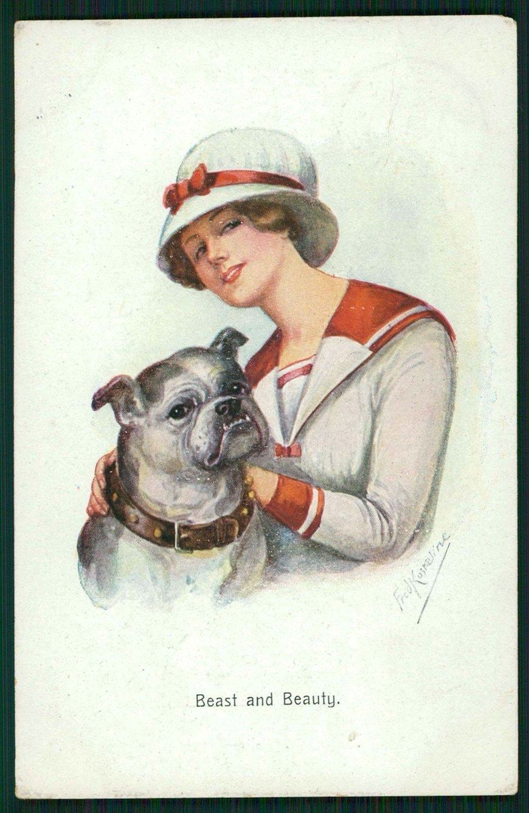
MARCH 2024 SPECIALTY SHOWS – Ric Brown.

TROPHIES & SUPPORTED SHOWS – Tracy Kupel
JUDGES SELECTION – Kip Anderson

LEGISLATION – Anne Hier -

HISTORIAN – Anne Hier –

OLD BUSINESS –

NEW BUSINESS –
Picnic in August

ADJOURN

GOOD OF THE CLUB

PROGRAM – We will have a 15 minute video on the use of the AED (Automated External Defibrillator)

